Grade 4
Parts

Description: | Students will:  Draw a simple background and lock it into place.  Add a digital image of a machine (bicycle) to the project.  Analyze and trace component parts of the machine.  Name the parts.  Script the parts to move.  Use the Scriptor menu: when should this script run?  Title the project.  Write directions to help or hinder assembly.
Project View | 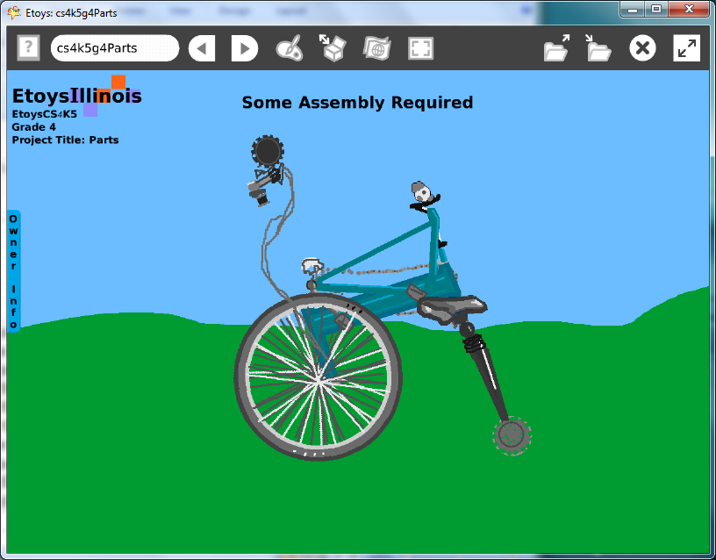
Subject: | Science, Mathematics, Art
Etoys Quick Guides | Click the question mark in Etoys to open the set of interactive tutorials for basic tools and techniques.
Vocabulary: | Analyze, assemble, disassemble, construct, deconstruct, center of rotation, mobile, kinetic art
Lesson 1:  Supplies: Digital Images  Script Tiles: Scale Factor  Paint Tools  Navigator Bar: Keep Find Projects | Give students a set of digital images and time to look at them and select their favorite.  Students will have reasons for which image they selected. Discuss.  Change the size of the image using the scale factor tile in its Viewer. Make it a size that fits the screen and the paint tool scrim.  The digital image can be kept or discarded as the student decides but in both cases the web site should be credited with a link.  Paint/trace each visible part, each with its own paint palette. Name the part after closing the palette; e.g. wheel, seat etc.  Give students time to think and to draw at the smallest part level where they are comfortable.  Keep the project: nameParts, e.g. KateParts
Lesson 2:  Script Tiles: Turn  Menus: Scriptor Icons Set | The set of parts are now going to be scripted and the whole project will become a mobile or kinetic art. Students will choose which parts they want to see move: specify how much and, when.  Script one of the parts: forward or turn.  Click and hold down on the word Normal in the top of the Scriptor.  Give students time to experiment with the menu: When should this script run? This menu has options beyond normal, ticking, and paused.  This menu adds another level of control over the objects and scripts in a project. Some students may want to use all of them in one project while others may want to use one of them for every part. These kinds of decisions give students practice in analysis. They should be able to explain what they chose and why. Discuss.  Give students time to script every part they want to see move.  Keep the project.
Lesson 3  Supplies: Text  Supplies: Add a New Flap | Type or draw a title for the project.  Type directions to the new owner. The directions in this example project are a spoof of confusing and incomplete directions.  Directions can be open or in a flap.  Keep the project.  Give students time to experiment with other students’ projects. Give them time to edit their project. Ask students to explain what changes they made and why.  Keep the project.
Standards: | Common Core Standards  Mathematics Practices: 1-8; 4.NF.6, 4.MD.1; 4.G1.2.3  Language Arts: 4.W.2.d  Bloom’s Taxonomy/Cognitive Domain:  Knowledge: knows, names  Application: uses, constructs, changes  Analysis: analyzes, compares, experiments  Synthesis: explains, modifies  NETS  1. c  3. b  4. a, b, c, d  5. a
Resources: | Etoys Help Quick Guides: always available in Etoys. Open Etoys and click the question mark to open a set of interactive tutorials of basic tools and techniques.  www.etoysillinois.org projects, lesson plans, software download  www.mste.Illinois.org more math, science, and technology resources  www.corestandards.org Common Core Standards  www.squeakland.org software and Etoys projects  www.nctm.org Standards and Focal Points for each grade level
kh
January 2011

